 | Cambridge Maths Stage 2  Name: ………………………………………………….  Class: …………… Date: ………………………
Homework Week 1- Unit 1: Numbers to 100
Task 1: Fill in the missing numbers.
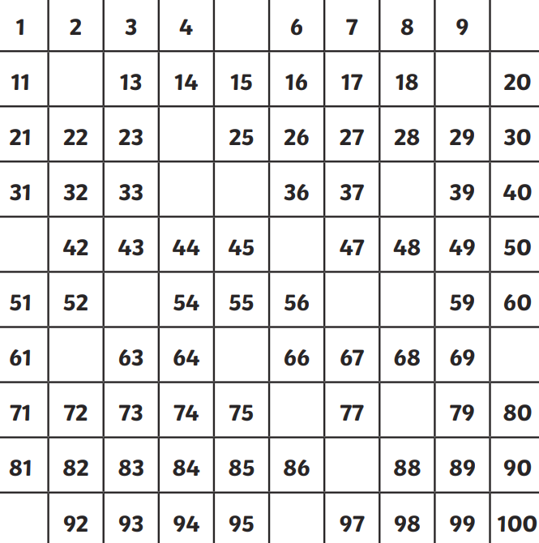
Task 2: Fill in the table using tens and ones. 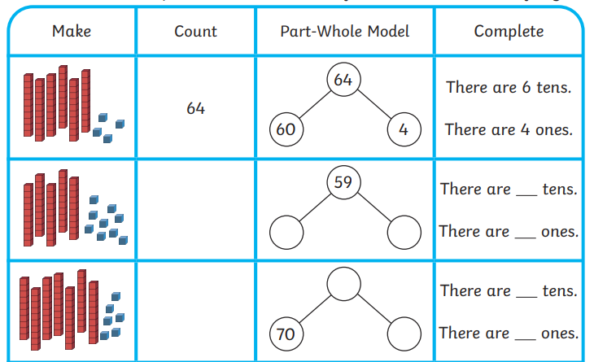

Task 3: Practice correct number and letter fromation for numbers one to ten.
